Fit curves (MATLAB script)

Last updated: 13.03.19 (NM)

Created: 13.03.19 (NM)

This MATLAB script fits either a linear or hyperbolic function to time-series data (e.g., growth data).

For working example, follow described procedure using growthData.xlsx provided in the SOP folder.

# Procedure

1. Data must first be prepared in an appropriate input format prior to analysis in MATLAB. Two input formats in *Microsoft Excel* are accepted:

**Format 1**

Prepare excel sheet with 5 columns labels: ID, condition, DOB, DOD, outcome (**Fig 1,** *left*):

* **ID**: numerical value used to identify sample (e.g., mouse)
* **condition**: categorical variable, specifies condition (e.g., M fat wt vs. M fat het)
* **DOB**: date of birth (YYYY-MM-DD)
* **DOD**: date of death (YYYY-MM-DD)
* **outcome**: dependent variable (e.g., weigth)

**Format 2**

Prepare excel sheet with 4 columns labels: ID, condition, age, outcome (**Fig 1,** *right*):

* **ID**: numerical value used to identify sample (e.g., mouse)
* **condition**: categorical variable, specifies condition (e.g., M fat wt vs. M fat het)
* **age**: age of sample (numerical value, e.g., 50.2)
* **outcome**: dependent variable (e.g., weight)

|  |  |
| --- | --- |
|  |  |
| **Figure 1**. Data input examples. Format 1 (*left*) and Format 2 (*right*) are shown. | |

1. Save excel sheet (.xlsx format) in same folder as ‘*fitData.m*’
2. Open ‘*fitData.m*’ in MATLAB and specify analysis parameters (**Fig 2**):
   * **file**: name of excel file with input data (e.g., ‘*growthData.xlsx*’)
   * **sheet**: name of excel sheet where input data is stored (e.g., ‘*example*)
   * **model:** specifies which model to fit to data (e.g., *‘hyperbolic’*)
     + Hyperbolic**:** y=(a*x)/(b+x)
     + where a = max value, b = x at y half max
     + Linear**:** y=a*x + b

where a = slope, b = intercept

* + **saveResults**: Specifies whether results are saved to new excel file (e.g., true)
  + **nBootStraps**: number of sampling iterations for bootstrap method (e.g., 100)
  + **ageOutputUnits**: if format 1 data input was selected, this property will allow you to specify which units to express time in (e.g., ageOutputUnits = 2 will result in time expressed as weeks (see legend below))
    - 1: days
    - 2: weeks
    - 3: months

|  |
| --- |
|  |
| **Figure 2**. Specifying analysis parameters in MATLAB |

1. Press ‘RUN’ in MATLAB

# Outputs.

1. MATLAB will output graphical results and (optionally) save numerical results to new Excel file.
2. Results are saved to new Excel file named [File RESULTS currentTime] and stored in four sheets:
   * **Summary**: reports mean, median, std, sem for each regression parameter, and results are stratified by condition. (**Fig 3**)
   * **Statistics_regression coef A**: model parameter a (coefficient a) is compared between each condition in dataset. Sheet contains pairwise comparisons and corresponding means, sample sizes, standard errors, t-scores and p-values. (**Fig 3**)
   * **Statistics_regression coef B**:Same as above, but for coefficient b.

|  |
| --- |
|  |
| **Figure 3**. Results saved in ‘summary’ sheet |

|  |
| --- |
|  |
| **Figure 3**. Results saved in ‘Statistics_regression coef A’ sheet |

1. Graphical results include 3 figures (parameter histograms, fitted curves and curve comparison for each condition):

**Parameter histograms**

Distributions for all model parameters (coefficient a in *blue*, coefficient b in *red*) for each condition. Note that all x-axes are scaled equally allowing for direct comparisons between conditions along the vertical axis.

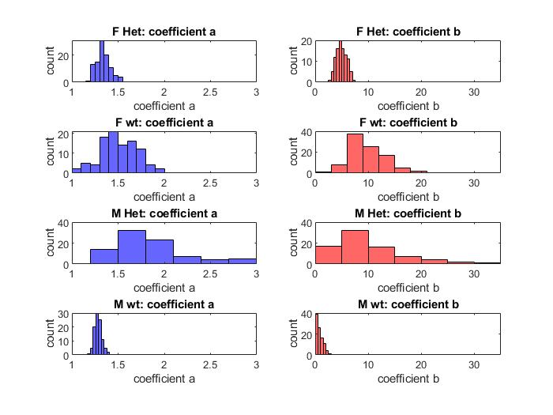

**Fitted curves**

Fitted curves for each condition shown along with 95% confidence interval (95% CI), 95% prediction interval (95% PI) and input data.

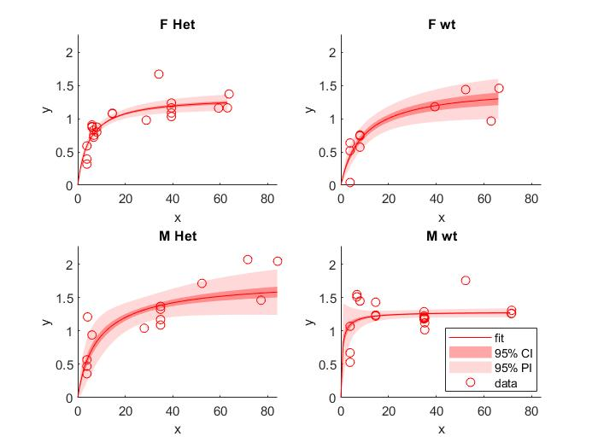

**Curve comparison**

Fitted curves ± 95% confidence interval for each condition on single axis.

